

**Report on**

Evaluation of means of finance and performance analysis of Eastland Insurance Company Limited

Submitted To:

Md Erfan

Assistant Professor

Department of Computer Science and Engineering

University Of Barishal

Submitted By

Debanjan Paul

**Roll:** 01-025-17

**Batch:** 25

**Course Name:** Computer Fundamentals and Office Application

**Class Roll:** 20 FIN 053

**Session:** 2019-2020

Department of Finance and Banking

Date of Submission: 05October,2024

Contents

Abstract 2

Introduction: 3

Objectives Of the Study 4

Methodology Including Detailed Analysis 4

Mission Of Eastland Insurance Company 5

Vision Of Eastland Insurance Company 5

Profitability Ratios Analysis:2019 9

Leverage ratios Analysis : 2019 9

Liquidity Ratios analysis : 2019 9

Profitability Ratios Analysis:2018 13

Leverage Ratios Analysis: 2018 13

Profitability Ratios Analysis :2017 13

Leverage Ratio analysis :2017 14

Profitability Ratios Analysis:2016 18

Leverage Ratio analysis : 2016 18

Liquidity ratios Analysis :2015 18

Profitability Ratios Analysis :2015 22

Leverage Ratios Analysis : 2015 22

Liquidity Ratios Analysis : 2015 22

Conclusion 30

**Acknowledgment**

I want to start by thanking God in the name of the Almighty for providing me the courage to finish this project paper. This study project was successfully completed thanks to the contributions of many, particularly those who took the time to give their thoughts and recommendations for how to improve the study. I want to thank, my supervisor and other faculties in the Department of Finance and Banking at the University of Barishal, for giving me all the advice and assistance I required. This was actually a good way to learn, and I appreciate my supervisor efforts to provide me with accurate information. I appreciate the authors and scientists whose research articles and publications I read, analyzed, and studied for this essay. Finally, I want to sincerely thank my family and friends for supporting me and providing me with their insights, and supporting me emotionally as I prepared my report. I'm also accountable for any errors in this study.

# Abstract

This research is conducted on Eastland Insurance Company Limited. It is accomplished on the “The Evaluation of means of finance and performance analysis of Eastland Insurance Company Limited”. This study also includes the information on the overview of Eastland Insurance Company Limited, theoretical analysis of insurance and legal framework of insurance industry Bangladesh on. This research is prepared primarily to have clear and real life ideas about the position of Eastland Insurance Company in insurance sector of Bangladesh. The research focuses on the major challenges of insurance industry in Bangladesh that obstruct smooth development of Bangladesh. This study conveys the message that if the insurance companies are operated very smoothly, the insurance sector will flourish very fast way.

# Introduction:

From the beginning of the human society, man has wanted the safety for himself, for his family and for his next generation. Although such expectation of safety is natural, man has never been able to assure it. Human life is completely surrounded by various types of risks and perils. To cover the losses occurred from such type of risks and perils, the insurance business has been originated. Insurance is the system of spreading the risk of one to the shoulders of many. It can be defined as a co-operative device to spread the loss caused by a particular risk over a number of persons who are exposed to it and who agree to ensure themselves against that risk. It is a contract whereby the insurer, on receiving of a consideration known as premium, agrees to indemnify the insured against losses arising out of certain specified unforeseen contingencies or perils. It can play an important role in a country’s economy. It is an old form of financial practice of sharing risk which was introduced in this area in mid-18th century.

Insurance business of Bangladesh has a long history of evolution. About a century back, couple of insurance companies started both non-life and life insurance business during the British regime in India. After the emergence of the People’s Republic of Bangladesh in 1971, the government nationalized the insurance industry along with the banks in 1972 by Presidential Order No. 95. By virtue of this order, all companies and organization transacting all types of insurance business in Bangladesh came under this nationalization order. This was followed by creation of five insurance companies in the life and non-life sector. Further changes were brought on 14th May, 1973. Through the enactment of Insurance Corporation Act VI, 1973, this led to creation of two corporations namely Sadharan Bima Corporation for general insurance and, Jiban Bima Corporation for life insurance in Bangladesh. In other words, Sadharan Bima Corporation (SBC) emerged on 14th May, 1973 under the Insurance Corporation Act (Act No. VI) of 1973 as the only state owned organization to deal with all classes of general insurance & reinsurance business emanating in Bangladesh. Thereafter SBC was acting as the sole insurer of general insurance till 1984. Bangladesh government allowed the private sector to conduct business in all areas of insurance for the first time in 1984. The private sector availed the opportunity promptly and came forward to establish private insurance companies through promulgation of the Insurance Corporations (Amendment) Ordinance (LI of 1984) 1984.

The Insurance Market in Bangladesh now consists of two state-owned corporations, a total of 77 insurance companies. Thus, the insurance sector in Bangladesh has grown up substantially and deepened remarkably with number of companies in both life and general segments. With the expansion of size of the insurance market, the volume of assets of the industry has also increased substantially. SBC is entitled to 50% of public sector business. Insurance Corporation (Amendment) Act 1990 provides that fifty percent of all insurance business relating to any public property or to any risk or liability appertaining to any public property shall be placed with the SBC and the remaining fifty percent of such business may be placed with this corporation or with any other insurers in Bangladesh. But for practical reason and in agreement with the Insurance Association of Bangladesh, SBC underwrites all the public sector business and 50% of that business is distributed among the existing 43 private general insurance companies equally under National Co-insurance Scheme. In respect of reinsurance, the same act provides that fifty percent of a company’s reinsurance business must be placed with the Sadharan Bima Corporation and remaining fifty percent may be reinsured either with this Corporation or with any insurer in Bangladesh or abroad. At present, nearly all the companies place 100% of their reinsurance business with the SBC. The activities of main two insurance companies are:

1. Sadharan Bima Corporation for transacting general insurance business only. The two general insurance corporations were merged under it.

2. Jiban Bima Corporation for transacting life insurance business only. The two life insurance corporations were merged under it.

## Objectives Of the Study

The objectives of the study are following:

*To analyze the performance Of Eastland Insurance Company Limited.

* To know about the current situation of insurance business in Bangladesh

* To know the reason behind the inefficiency of insurance business in Bangladesh

* To develop our skill about insurance policy.

## Methodology Including Detailed Analysis

Correct and smooth completion of research work requires adherence to some rules and methodologies. In order to conduct the research, we have decided to collect various types of primary and secondary data. Different form of statistical configurations such as percentages rates and ratios has been used to make the study meaningful and realistic. After collecting data from the interview and interview data has been first carefully scrutinized. Then the data was organized as required. In order to make the study effective and efficient, following two sources of data have been used widely.

(a) Primary Data: The primary data have been collected by oral interviewing the responsible officers and staffs of the Eastland Insurance Company Ltd. We also get the primary information by observing the various departments of the Eastland Insurance Company Ltd.

(b) Secondary data :The main source of published data is the auditors’ statements of financial affairs, which are basically used internally by the corporation. Data are also collected from secondary sources like-Annual Reports, Bangladesh Insurance Academy and Insurance Development & Regulatory Authority etc.

## Mission Of Eastland Insurance Company

|  |
| --- |
| *To create and deliver risk solutions and services that makes our clients risk-free and successful.  *To be among its peers in the market by providing fastest personalized services to the clients through utmost good faith, good conduct, sincerity and integrity. |
|  |

## Vision Of Eastland Insurance Company

*To well being of the society at large through comprehensive insurance protection and creative investment.  
  
*To double sales revenue over the next five years by providing maximum security for the properties of the existing and potential clients.

Easltand Insurance Company limited

Balance sheet

As at 31 December,2019

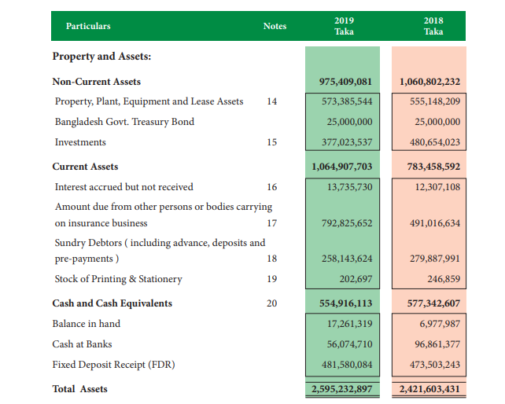

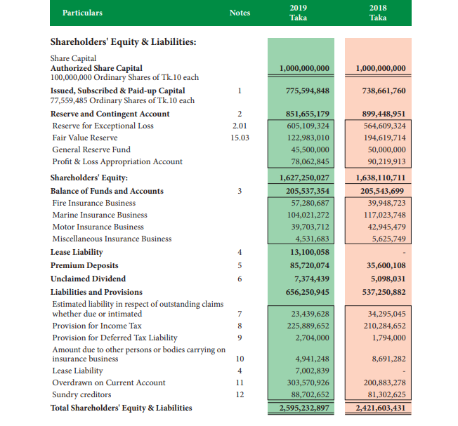

Eastland Insurance Company Limited

Profit and loss account

As at 31 December, 2019

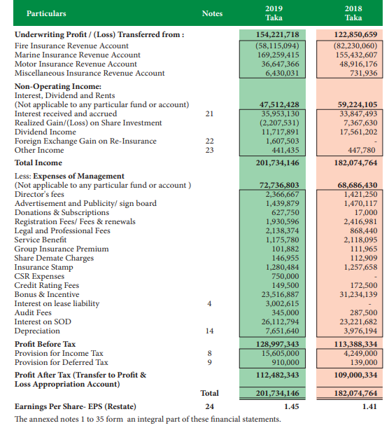

### Profitability Ratios Analysis:2019

>Return on Total Assets (ROA)= Earnings available for Common stockholders ÷Total Assets=

(201,734,116÷ 2,595,232,897)= 7.77%

>Return On Common Equity(ROE) = Earnings available for coomon stockholders ÷Total Equity )

(201,735,116 ÷ 1,627,250,027) = 12.39%

> EPS = Earnings available for common stock holders ÷ Total numbers of shares Common stock = 1.45

### Leverage ratios Analysis : 2019

* Debt To-assets Ratio = ( Total Debt ÷ Total Assets )

(967,982,870÷ 2,595,232, 897) = 37.29%

* Debt to-Equity Ratio = ( Total Debt ÷ Total Equity )

(967,982,870 ÷1,627,250,027 ) =0.59%

* Debt To-Capital ratio = Total Debt ÷( total debt+ total equity )

967,982,870 ÷( 967,982,870+1,627,250,027)

= 37.29%

* Asset To Equity ratio =( total assets ÷ Total Equity)

(2,595,232,897 ÷ 1,627,250,027) =

1.59%

### Liquidity Ratios analysis : 2019

* Current Ratio = (Current Assets÷Current Liabilities)

(1,064,907,703÷ 46,706,783)= 2.28:1

Eastland Insurance Company Limited

Balance Sheet

As at 31 December,2018

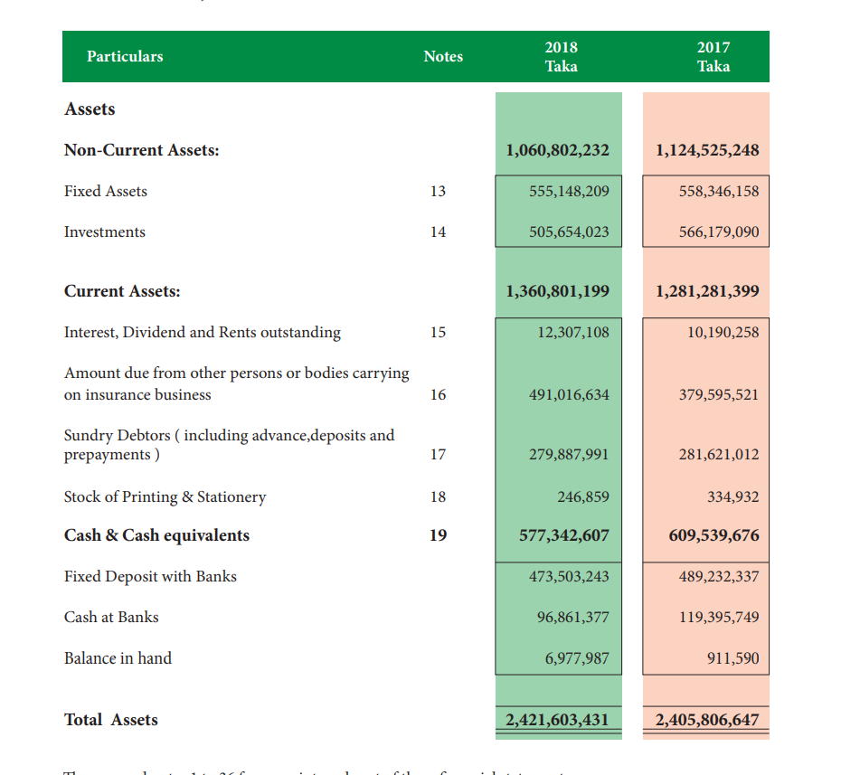

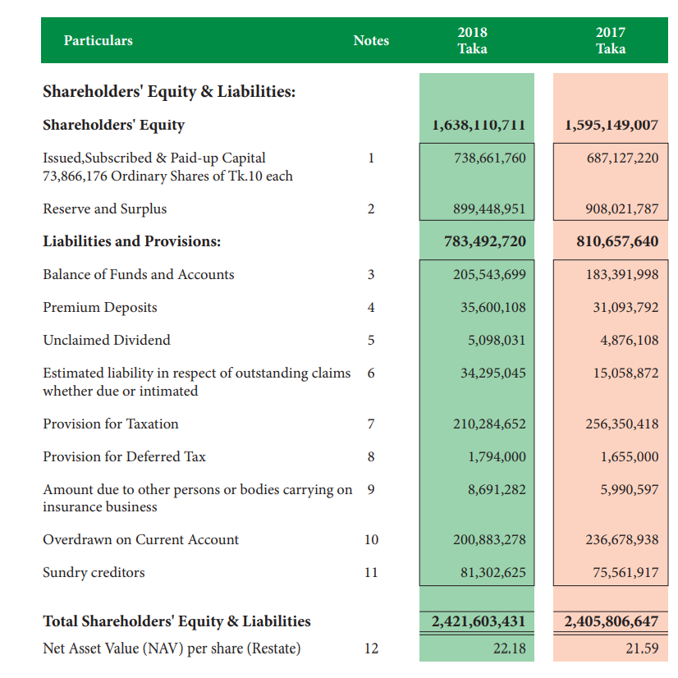

Eastland Insurance Company Limited

Profit and Loss account 2.02

For the Year Ended 31 December,2018

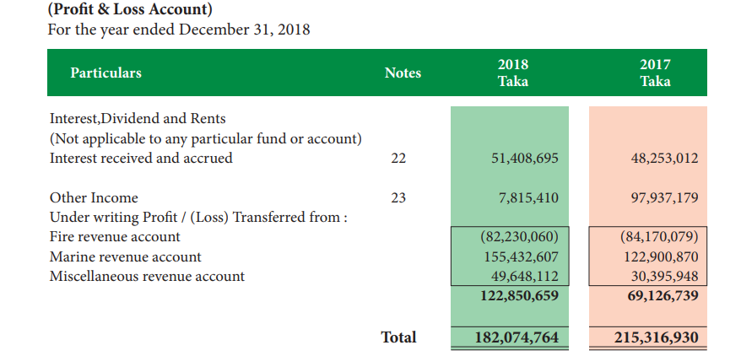

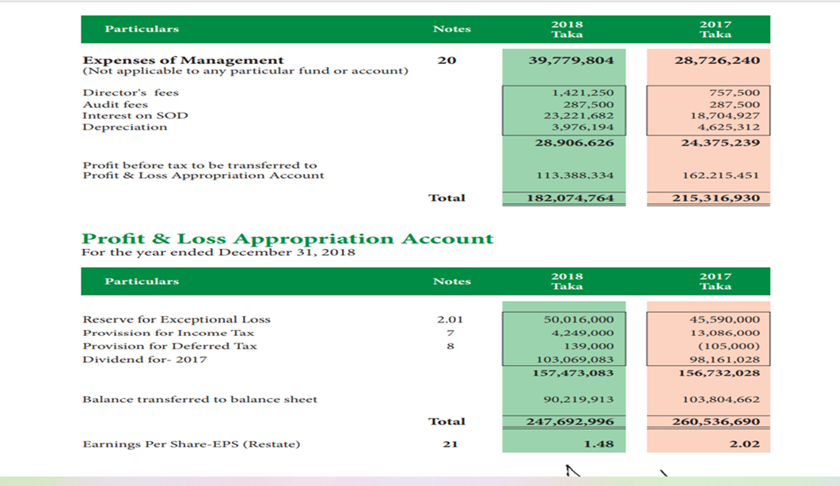

### Profitability Ratios Analysis:2018

>Return on Total Assets = (Earnings available for Common Stockholders÷ Total Assets) (182,074,764 ÷ 2,421,603,431) = 7.52%

> Return on Common Equity = (Earnings available For Common Stockholders÷ Common stock Equity )

( 182,074,764÷ 1,638,110,711) =11.11%

* Eps = Earnings available For Common stockholders ÷ Numbers Of shares Common stock) = 1.48

### Leverage Ratios Analysis: 2018

* Debt To-Assets Ratio = Total Debt÷ Total Assets

(783,492,720÷ 2,421,603,431)= 32.35%

* Debt to-Equity Ratio=( Total Debt ÷ Total Equity )

( 783,492,720÷ 1,638,110,711) = 0.47

* Debt to- capital Ratio = total Debt ÷ (Total Debt + Total Equity)

783,492,720÷ ( 783,492,720 +1,638,110,711)=32.35

* Assets To equity Ratio = ( Total Assets ÷ Total Equity )

(2,421,603,431÷1,638,110,711)=1.49

Liquidity Ratios Analysis:2018

Current Ratio = ( current assets ÷ current Liabilities)

(783458592 ÷ 302,493,664)=2.59:1

Liquidity Ratios analysis :2017

Current ratio= current assets ÷ current liabilities

(1,281,281,399÷ 538353529)=2.38:1

### Profitability Ratios Analysis :2017

* Return On Total assets (ROA)= (earnings available For Common stockholders ÷ Total Assets )

(215,316,930 ÷ 2,405,806,647)=8.95%

* Return on Common Equity (ROE)= (Earnings available for Common stockholders ÷ Common stock Equity )

(215,316,930÷ 810,657,640)= 26.56%

* EPS = Earnings available for common stockholders ÷ numbers of shares common stock = 2.02

### Leverage Ratio analysis :2017

* Debt to asset ratio : (Total Debt ÷ Total assets)

(1,595,149,007 ÷ 2,405,806,647)= 66.30%

* Debt to- Equity ratio: (total Debt÷ Total Equity)

(1,595,149,007 ÷810,657,640) = 1.97

* Debt to capital Ratio = Total debt ÷ ( total debt + Total Equity)

1,595,149,007÷ (1,595,149,007 +810,657,640)= 66.30%

* Assets To Equity Ratio = Total assets÷ total equity

(2,405,806,647÷810,657,640)=2.97

Eastland Insurance Company Limited

Balance sheet

As at 31 December,2016

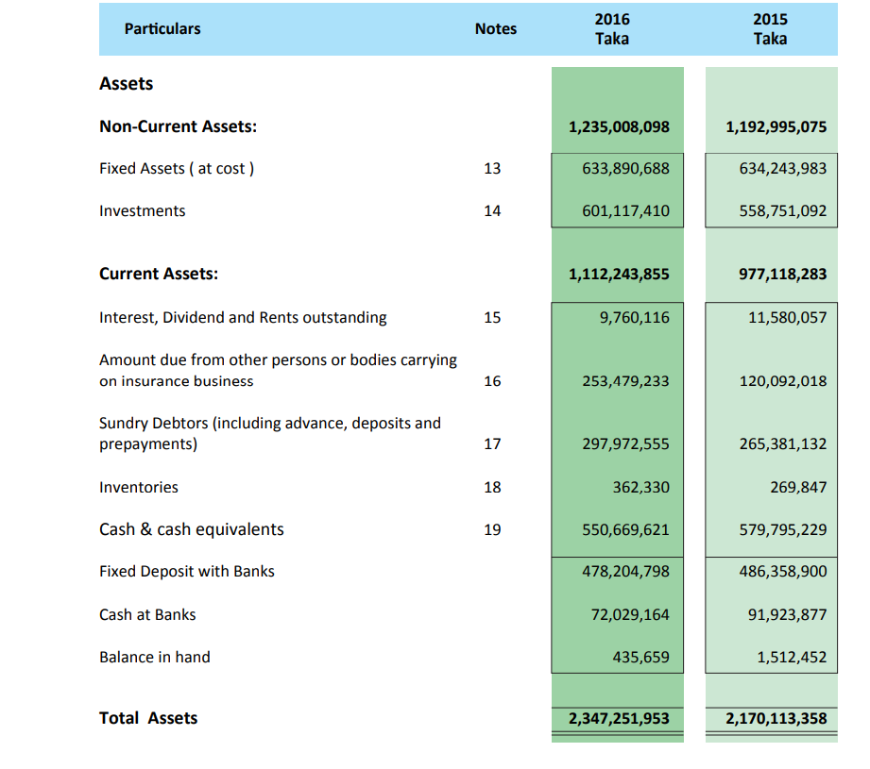

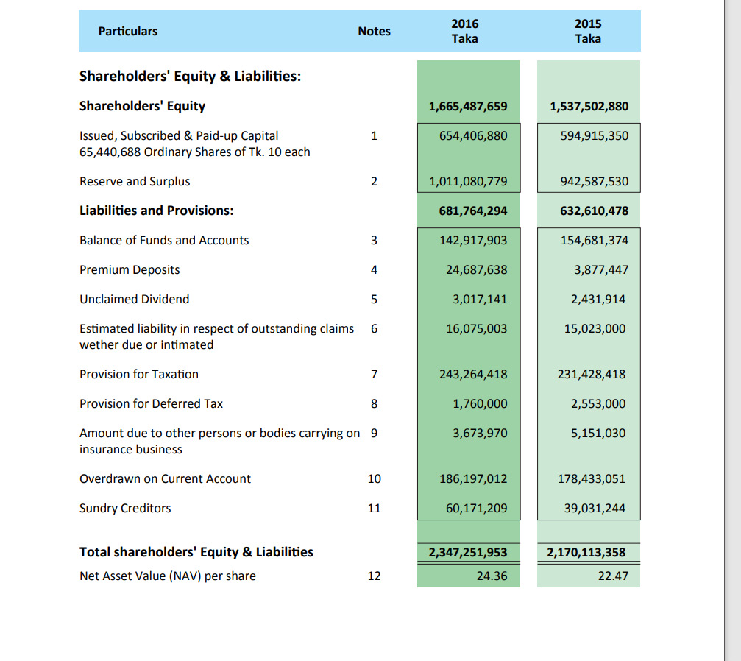

Eastland Insurance company Limited

Balance Sheet

As at 31 December,2016

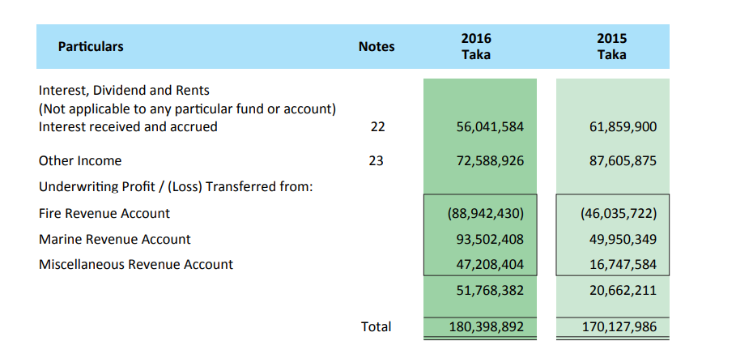

/

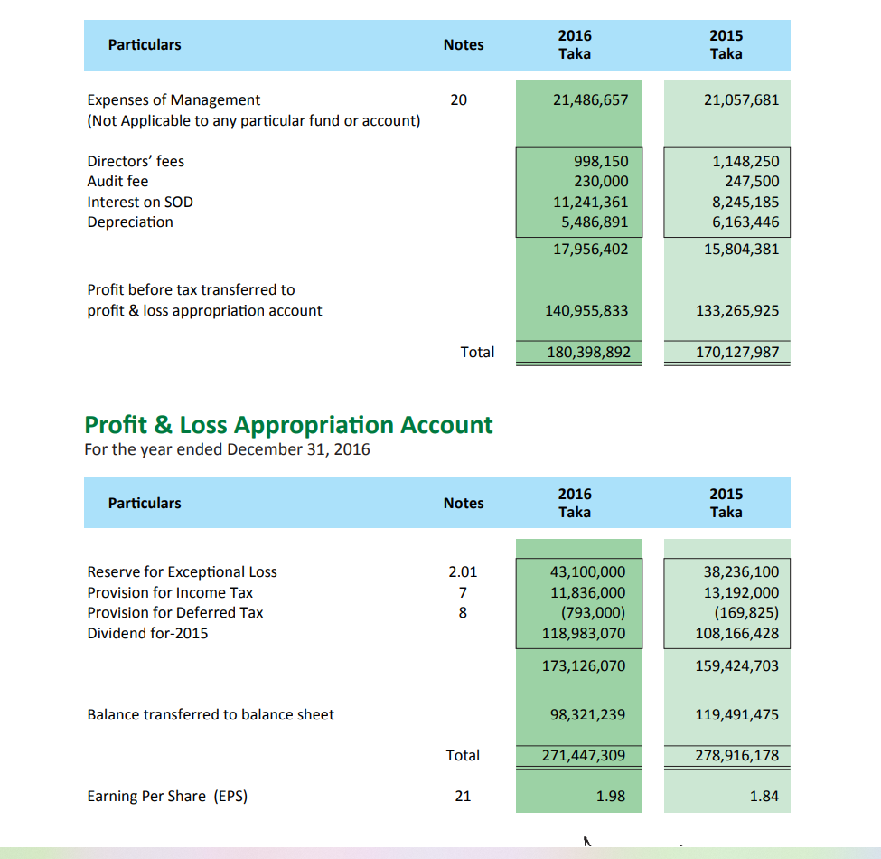

### Profitability Ratios Analysis:2016

* Return On Total ASSETS = Return On Total assets (ROA)= (earnings available For Common stockholders ÷ Total Assets )

(180,398,892 ÷ 2,347,251,953)= 7.69%

* Return On Common Equity =(earnings available For Common stockholders ÷ Common stock equity)

( 180,398,892 ÷ 681,764,294)= 26.46%

* EPS = (earnings available For Common stockholders ÷ Numbers of shares common Stock)=1.98

Liquidity Ratios Analysis ; 2016

* Current Ratio = Current Assets ÷ current Liabilities) = 2.42

### Leverage Ratio analysis : 2016

* Debt To –Assets Ratio= (Total Debt ÷ Total assets)

(1,665,487,659÷ 2,347,251,953)= 70.95%

* Debt to Equity Ratio =(total Debt÷ Total Equity)

(1,665,487,659÷ 681,764,294)= 26.46%

* Debt to capital Ratio: = Total debt ÷ ( total debt + Total Equity)

1,665,487,659÷(1,665,487,659+ 681,764,294)= 70.95%

* Asset To Equity Ratio = (total Assets ÷ Total Equity)

(2,347,251,953÷ 681,764,294)= 3.44

### Liquidity ratios Analysis :2015

* Current assets = ( current assets current liabilities)

( 1112243855÷ 459604898)=2.42:1

Eastland Insurance Company Limited

Balance Sheet

As at 31 December,2015

Particulars notes 2015 2014

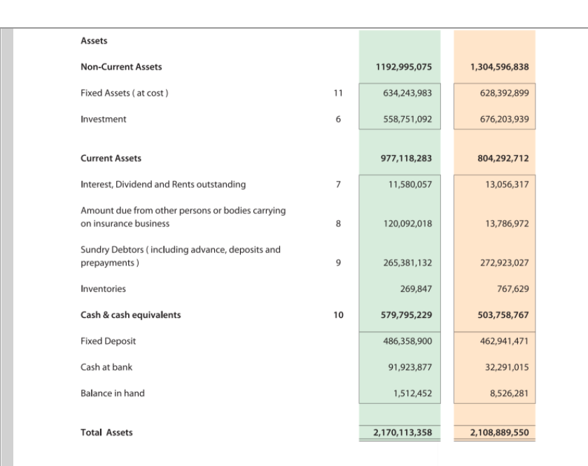

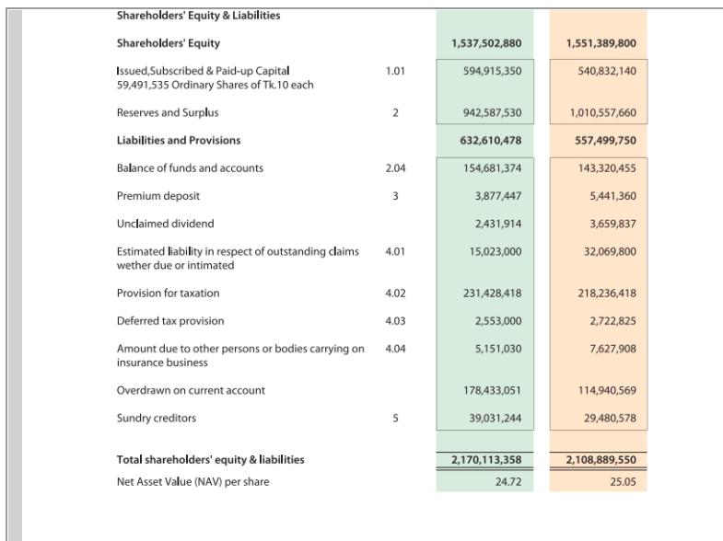

Eastland Insurance Company Limited

Profit And Loss Account

As at 31 December, 2015

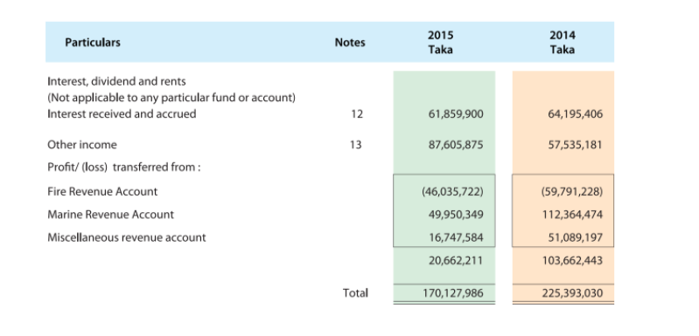

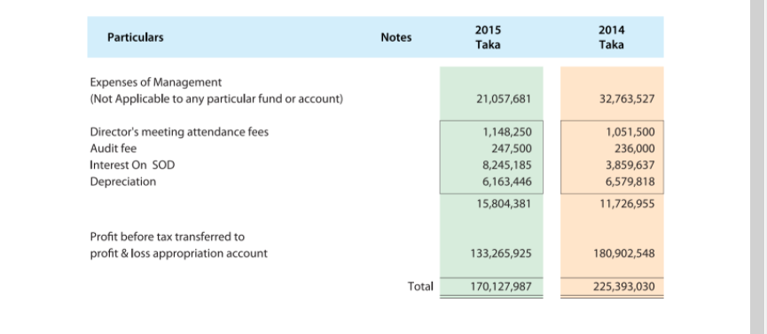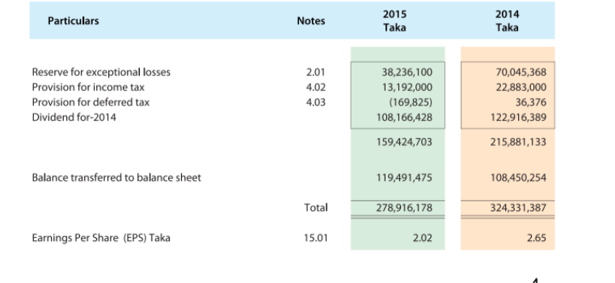

### Profitability Ratios Analysis :2015

* Return On Total Assets = ( Earnings avialable for common stockholders Total assets )

(170,127,986 ÷ 2,170,113,358)

* Return on Common equity = ( Earnings avialable for common stockholders ÷
* Common stock equity )

( 170,127,986 ÷ 632,610,478)

* EPS= Earnings avialable for common stockholders ÷ Common stock equity ) = 2.02

### Leverage Ratios Analysis : 2015

* Debt to Assets Ratio= (Total Debt ÷ Total Equity )

( 1,537,502,880 ÷ 2,170,113,358)= 70.85%

* Debt To Equity Ratio= ( Total Debt ÷ Total Equity)

(1,537,502,880 ÷ 623,610,478)

* Debt to capital Ratio: = Total debt ÷ ( total debt + Total Equity)

1,537,502,880 ÷ ( 1,537,502,880 +623,610,478)=70.85%

* Asset TO Equity Ratio= ( Total Assets ÷Total Equity )

(2,170,113,358÷ 623,610,478)=3.43

### Liquidity Ratios Analysis : 2015

* Current Ratio = (Current Assets ÷ Current Liabilities)

(977118283 ÷ 383183640)= 2.55:1

* We have mentioned the Mathematical Analysis of the ratios mentioned in the previous . Now we will show the Graphical analysis of the ratios.

Profitability means the ability of a company to earn a profit. Firm’s profitability is very important both for stockholders and creditors because revenue in the form of dividends is being derived from profits, as well as profits are one source of funds for covering debts. Profitability ratio analysis is a good way to measure company’s performance. Profitability ratios can be divided into two types: margins, indicating the firm’s ability to transform money from sales into profits, and returns, showing the ability of a company to generate returns for its shareholders.

Return on total assets (ROA) is a ratio that measures a company's [earnings](https://www.investopedia.com/terms/e/earnings.asp) before interest and taxes (EBIT) relative to its total net assets. It is defined as the ratio between net income and total average assets, or the amount of financial and operational income a company receives in a financial year as compared to the average of that company's total assets.The ratio is considered to be an indicator of how effectively a company is using its [assets](https://www.investopedia.com/terms/a/asset.asp) to generate earnings.

Return On Total Assets

The **return on equity ratio** or **ROE** is a profitability **ratio** that measures the ability of a firm to generate profits from its shareholders investments in the company. ... This is an important measurement for potential investors because they want to see how efficiently a company will use their money to generate net income.

**Earnings per share** (**EPS**) **ratio** measures how many dollars of net income have been earned by each share of common stock during a certain time period. It is computed by dividing net income less preferred dividend by the number of shares of common stock outstanding during the period.

|  |  |  |  |  |  |
| --- | --- | --- | --- | --- | --- |
| Year | 2015 | 2016 | 2017 | 2018 | 2019 |
| EPS | 2.02 | 1.98 | 2.02 | 1.48 | 1.45 |

Leverage Ratios Analysis: A Leverage ratio is any kind of [financial ratio](https://corporatefinanceinstitute.com/resources/knowledge/finance/financial-analysis-ratios-glossary/) that indicates the level of debt incurred by a business entity against several other accounts in its [balance sheet](https://corporatefinanceinstitute.com/resources/knowledge/accounting/balance-sheet/), [income statement](https://corporatefinanceinstitute.com/resources/knowledge/accounting/income-statement/), or [cash flow statement](https://corporatefinanceinstitute.com/resources/knowledge/accounting/cash-flow-statement%e2%80%8b/).  These ratios provide an indication of how the company’s assets and business operations are financed (using debt or equity). Below is an illustration of two common leverage ratios: debt/equity and debt/capital.

The **debt to asset ratio** is commonly used by analysts, investors, and creditors to determine the overall risk of a company. ... It indicates that the company is highly leveraged. A ratio greater than one (>1) means the company owns more liabilities than it does assets.

Debt To Assets Ratio

The debt-to-equity (D/E) ratio compares a company's total liabilities to its shareholder equity and can be used to evaluate how much leverage a company is using. Higher leverage ratios tend to indicate a company or stock with higher risk to shareholders.

The total **debt to capitalization ratio** is a solvency measure that shows the proportion of debt a company uses to finance its assets, relative to the amount of equity used for the same purpose. A higher ratio result means that a company is more highly leveraged, which carries a higher risk of insolvency.

Debt To Capital Ratio

The asset/equity ratio shows the relationship of the total assets of the firm to the portion owned by shareholders. This ratio is an indicator of the company’s leverage (debt) used to finance the firm.

Asset / Equity Ratio

Liquidity ratios are an important class of financial metrics used to determine a debtor's ability to pay off current debt obligations without raising external capital.

The current ratio is a [liquidity](https://www.myaccountingcourse.com/financial-ratios/liquidity-ratios)  that measures a firm’s ability to pay off its short-term liabilities with its current assets. The current ratio is an important measure of liquidity because short-term liabilities are due within the next year.

|  |  |  |  |  |  |
| --- | --- | --- | --- | --- | --- |
| Year | 2015 | 2016 | 2017 | 2018 | 2019 |
| Current Ratio | 2.55 | 2.42 | 2.38 | 2.59 | 2.28 |

# Conclusion

Finance and performance analysis evaluates a company’s financial health and operational efficiency through key metrics like profitability, liquidity, and solvency. It helps stakeholders make informed decisions, identify strengths and weakness, and assess risks.